**Assignment 10 (Advance Programming)**

Name – Ankit Kharb

UID – 22BCS16964

# 118. Pascal's Triangle

Given an integer numRows, return the first numRows of Pascal's triangle.

In Pascal's triangle, each number is the sum of the two numbers directly above it as shown:

Example 1:

Input: numRows = 5

Output: [[1],[1,1],[1,2,1],[1,3,3,1],[1,4,6,4,1]]

Example 2:

Input: numRows = 1

Output: [[1]]

**Solution:**

class Solution {

public:

vector<vector<int>> generate(int numRows) {

vector<vector<int>> triangle;

for (int i = 0; i < numRows; ++i) {

vector<int> row(i + 1, 1); // initialize row with 1s

for (int j = 1; j < i; ++j) {

row[j] = triangle[i - 1][j - 1] + triangle[i - 1][j];

}

triangle.push_back(row);

}

return triangle;

}

};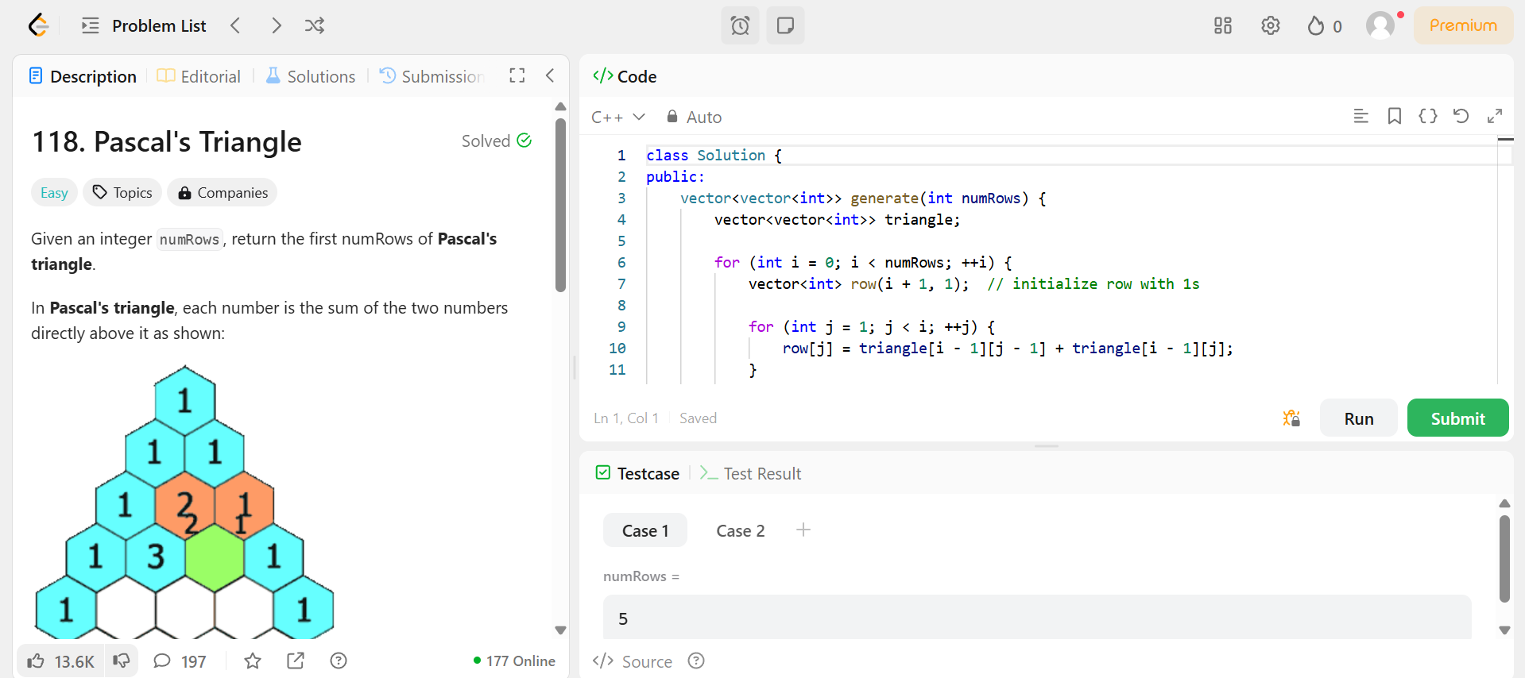

# 461. Hamming Distance

The Hamming distance between two integers is the number of positions at which the corresponding bits are different.

Given two integers x and y, return the Hamming distance between them.

Example 1:

Input: x = 1, y = 4

Output: 2

Explanation:

1 (0 0 0 1)

4 (0 1 0 0)

↑ ↑

The above arrows point to positions where the corresponding bits are different.

**Solution:**

class Solution {

public:

int hammingDistance(int x, int y) {

int xorVal = x ^ y;

int count = 0;

while (xorVal) {

count += xorVal & 1; // check last bit

xorVal >>= 1; // right shift

}

return count;

}

};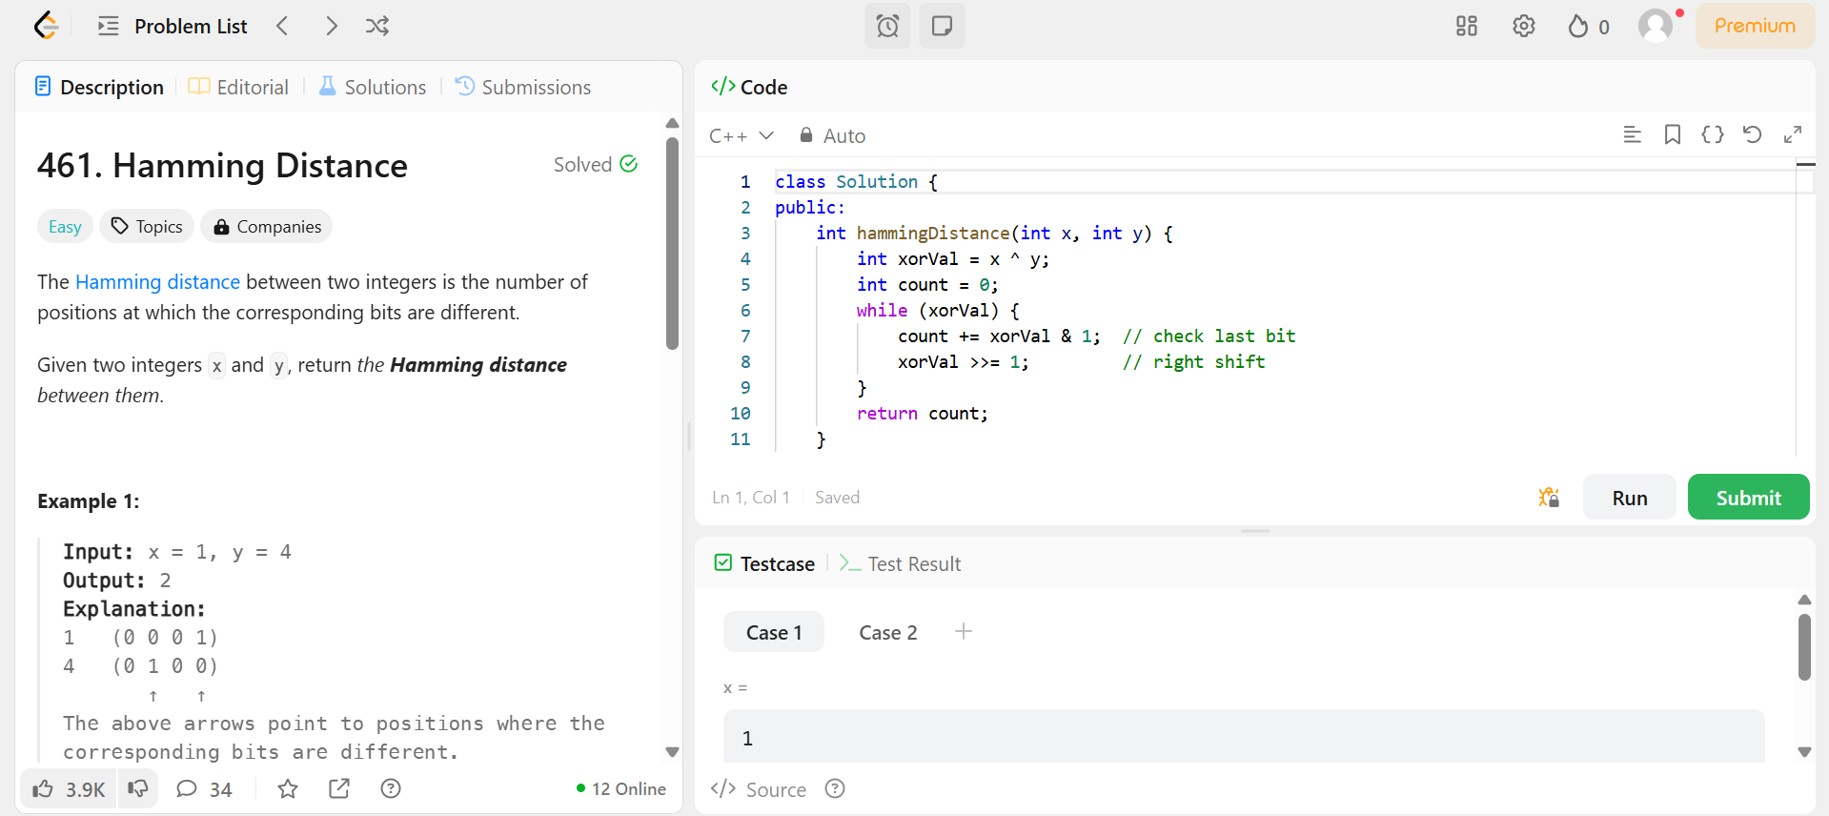

# 621. Task Scheduler

You are given an array of CPU tasks, each labeled with a letter from A to Z, and a number n. Each CPU interval can be idle or allow the completion of one task. Tasks can be completed in any order, but there's a constraint: there has to be a gap of at least n intervals between two tasks with the same label.

Return the minimum number of CPU intervals required to complete all tasks.

Example 1:

Input: tasks = ["A","A","A","B","B","B"], n = 2

Output: 8

Explanation: A possible sequence is: A -> B -> idle -> A -> B -> idle -> A -> B.

After completing task A, you must wait two intervals before doing A again. The same applies to task B. In the 3rd interval, neither A nor B can be done, so you idle. By the 4th interval, you can do A again as 2 intervals have passed.

**Solution:**

class Solution {

public:

int leastInterval(vector<char>& tasks, int n) {

vector<int> freq(26, 0);

// Count frequency of each task

for (char task : tasks) {

freq[task - 'A']++;

}

// Sort frequencies to get the task with maximum frequency at the end

sort(freq.begin(), freq.end());

int maxFreq = freq[25]; // Highest frequency

int maxFreqCount = 1;

// Count how many tasks have the same maximum frequency

for (int i = 24; i >= 0; i--) {

if (freq[i] == maxFreq) {

maxFreqCount++;

} else {

break;

}

}

// Calculate the minimum time using the greedy formula

int partCount = maxFreq - 1;

int partLength = n - (maxFreqCount - 1);

int emptySlots = partCount * partLength;

int availableTasks = tasks.size() - (maxFreq * maxFreqCount);

int idles = max(0, emptySlots - availableTasks);

return tasks.size() + idles;

}

};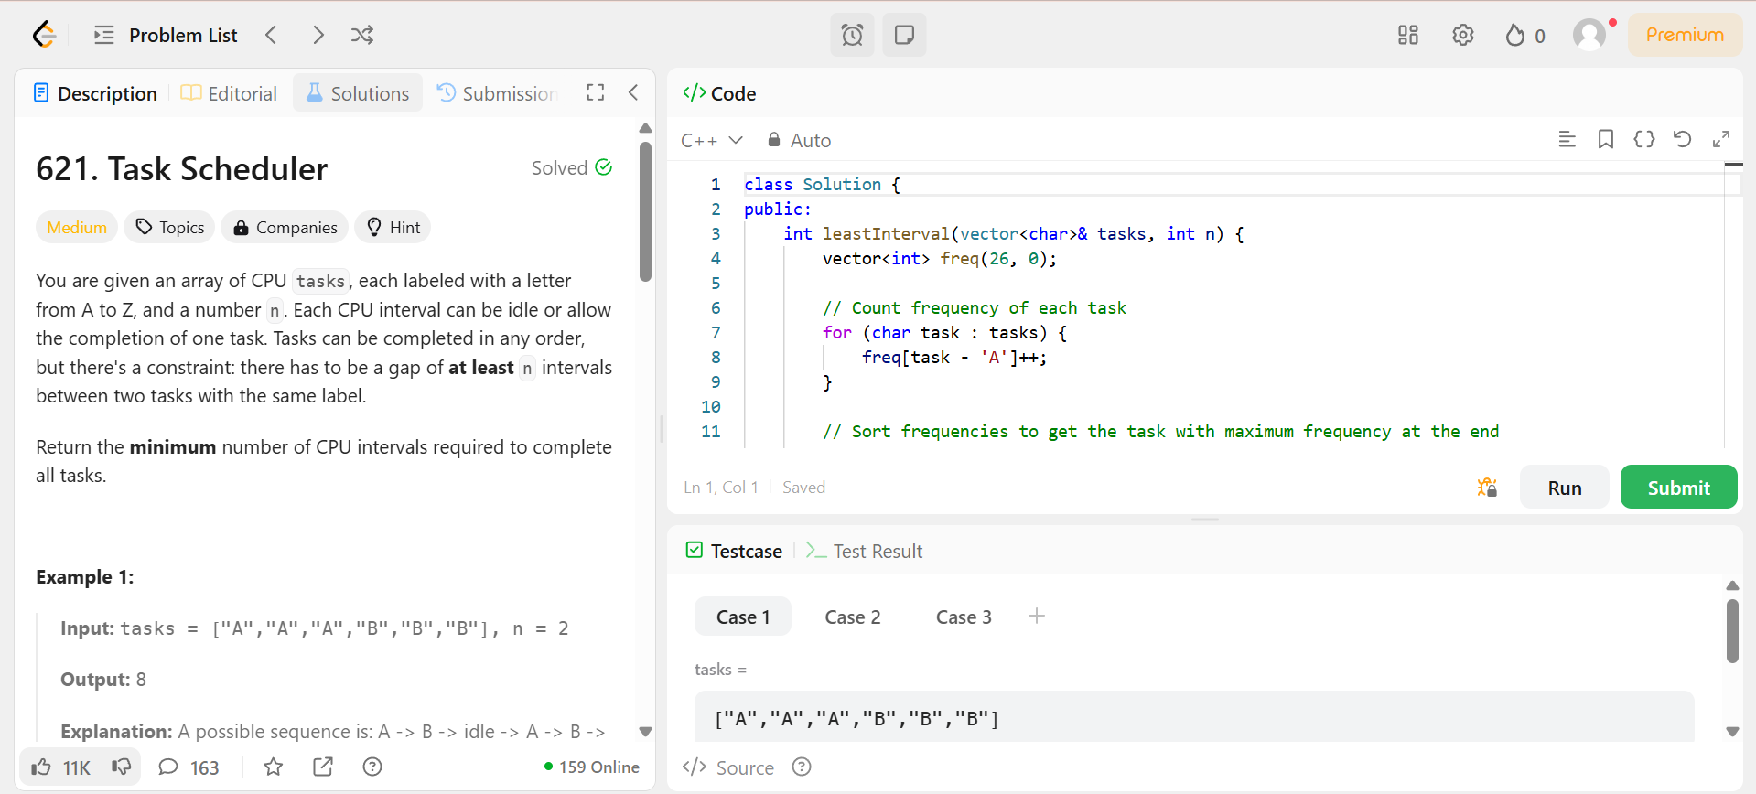

## 191. Number of 1 Bits

Given a positive integer n, write a function that returns the number of set bits in its binary representation (also known as the Hamming weight).

Example 1:

Input: n = 11

Output: 3

Explanation:

The input binary string 1011 has a total of three set bits.

Example 2:

Input: n = 128

Output: 1

Explanation:

The input binary string 10000000 has a total of one set bit.

**Solution:**

class Solution { public:

int hammingWeight(int n) { int count = 0; while (n != 0) { n = n & (n - 1); count++;

} return count;

};

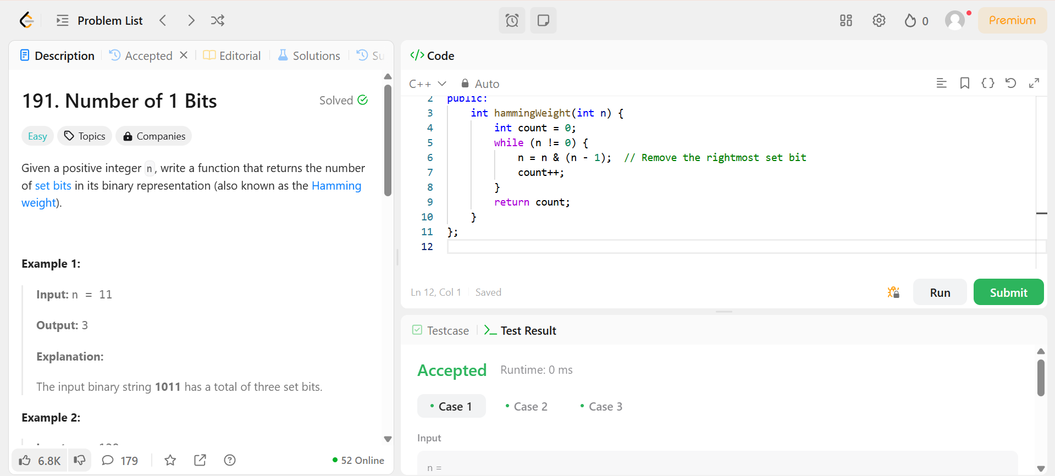

## 42. Trapping Rain Water

Given n non-negative integers representing an elevation map where the width of each bar is 1, compute how much water it can trap after raining.

Example 1:

Input: height = [0,1,0,2,1,0,1,3,2,1,2,1]

Output: 6

Explanation: The above elevation map (black section) is represented by array

[0,1,0,2,1,0,1,3,2,1,2,1]. In this case, 6 units of rain water (blue section) are being trapped.

**Solution:**

class Solution { public:

int trap(vector<int>& height) { int n = height.size(); if (n == 0) return 0; vector<int> left_max(n, 0); vector<int> right_max(n, 0);

left_max[0] = height[0]; for (int i = 1; i < n; ++i) {

left_max[i] = max(left_max[i-1], height[i]);

}

right_max[n-1] = height[n-1]; for (int i = n-2; i >= 0; --i) {

right_max[i] = max(right_max[i+1], height[i]);

}

int total_water = 0; for (int i = 0; i < n; ++i) {

total_water += min(left_max[i], right_max[i]) - height[i];

}

return total_water;

}

};

